**LAB SESSION 7: YET ANOTHER COMPILER COMPILER**

**AIM**: To learn YACC tool for syntax and semantic analysis and implement basic YACC Programs.

**PROBLEM DEFINITION:** Write YACC programs to:

1. Validate syntax of declaration statement for given input.
2. Parse an arithmetic expression of the form: num1 op num2
3. Evaluate the arithmetic expressions
4. Parse assignment statement

**THEORY:** Yacc generates C code for a syntax analyzer, or parser. Yacc uses grammar rules that allow it to analyze tokens from lex and create a syntax tree. A syntax tree imposes a hierarchical structure on tokens. For example, operator precedence and associativity are apparent in the syntax tree. The next step, code generation, does a depth-first walk of the syntax tree to generate code. Some compilers produce machine code, while others, as shown above, output assembly.

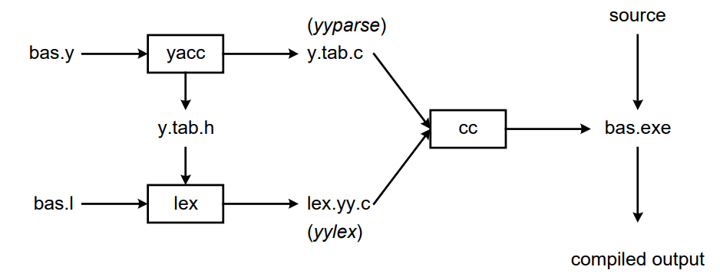

We'll assume our goal is to write a BASIC compiler. First, we need to specify all pattern matching rules for lex (bas.l) and grammar rules for yacc (bas.y). Commands to create our compiler, bas.exe, are listed below:

1. yacc –d bas.y # create y.tab.h, y.tab.c
2. lex bas.l # create lex.yy.c
3. cc lex.yy.c y.tab.c –obas.exe # compile/link

Yacc reads the grammar descriptions in bas.y and generates a parser, function yyparse, in file y.tab.c. Included in file bas.y are token declarations. These are converted to constant definitions by yacc and placed in file y.tab.h. Lex reads the pattern descriptions in bas.l, includes file y.tab.h, and generates a lexical analyzer, function yylex, in file lex.yy.c.

Finally, the lexer and parser are compiled and linked together to form the executable, bas.exe. From main, we call yyparse to run the compiler. Function yyparse automatically calls yylex to obtain each token.

Grammars for yacc are described using a variant of Backus Naur Form (BNF). This technique was pioneered by John Backus and Peter Naur, and used to describe ALGOL60. A BNF grammar can be used to express context-free languages. Most constructs in modern programming languages can be represented in BNF. For example, the grammar for an expression that multiplies and adds numbers is

1. E -> E + E
2. E -> E * E
3. E -> id

Three productions have been specified. Terms that appear on the left-hand side (lhs) of a production, such as E (expression) are nonterminals. Terms such as id (identifier) are terminals (tokens returned by lex) and only appear on the right-hand side (rhs) of a production. This grammar specifies that an expression may be the sum of two expressions, the product of two expressions, or an identifier. We can use this grammar to generate expressions:

E -> E * E (r2)

-> E * z (r3)

-> E + E * z (r1)

-> E + y * z (r3)

-> x + y * z (r3)

At each step we expanded a term, replacing the lhs of a production with the

corresponding rhs. The numbers on the right indicate which rule applied. To parse an expression, we actually need to do the reverse operation. Instead of starting with a single nonterminal (start symbol) and generating an expression from a grammar, we need to reduce an expression to a single nonterminal. This is known as bottom-up or shift-reduce parsing, and uses a stack for storing terms. Here is the same derivation, but in reverse order:

1. .x+y*z shift
2. x.+y*z reduce(r3)
3. E.+y*z shift
4. E+.y*z shift
5. E+y.*z reduce(r3)
6. E+E.*z shift
7. E+E*.z shift
8. E+E*z. reduce(r3)
9. E+E*E. reduce(r2) emit multiply
10. E + E . reduce(r1) emit add
11. E . accept

Terms to the left of the dot are on the stack, while remaining input is to the right of the dot. We start by shifting tokens onto the stack. When the top of the stack matches the rhs of a production, we replace the matched tokens on the stack with the lhs of the production. Conceptually, the matched tokens of the rhs are popped off the stack, and the lhs of the production is pushed on the stack. The matched tokens are known as a handle, and we are reducing the handle to the lhs of the production. This process continues until we have shifted all input to the stack, and only the starting nonterminal remains on the stack. In step 1 we shift the x to the stack. Step 2 applies rule r3 to the stack, changing x to E. We continue shifting and reducing, until a single nonterminal, the start symbol, remains in the stack. In step 9, when we reduce rule r2, we emit the multiply instruction.

Similarly, the add instruction is emitted in step 10. Thus, multiply has a higher precedence than addition.

Consider, however, the shift at step 6. Instead of shifting, we could have reduced,applying rule r1. This would result in addition having a higher precedence than multiplication. This is known as a shift-reduce conflict. Our grammar is ambiguous, as there is more than one possible derivation that will yield the expression. In this case, operator precedence is affected. As another example, associativity in the rule

E -> E + E

is ambiguous, for we may recurse on the left or the right. To remedy the situation, we could rewrite the grammar, or supply yacc with directives that indicate which operator has precedence. The latter method is simpler, and will be demonstrated in the practice section.

The following grammar has a reduce-reduce conflict. With an id on the stack, we may reduce to T, or reduce to E.

E -> T

E -> id

T -> id

Yacc takes a default action when there is a conflict. For shift-reduce conflicts, yacc will shift. For reduce-reduce conflicts, it will use the first rule in the listing. It also issues a warning message whenever a conflict exists. The warnings may be suppressed by making the grammar unambiguous. Several methods for removing ambiguity will be presented in subsequent sections.

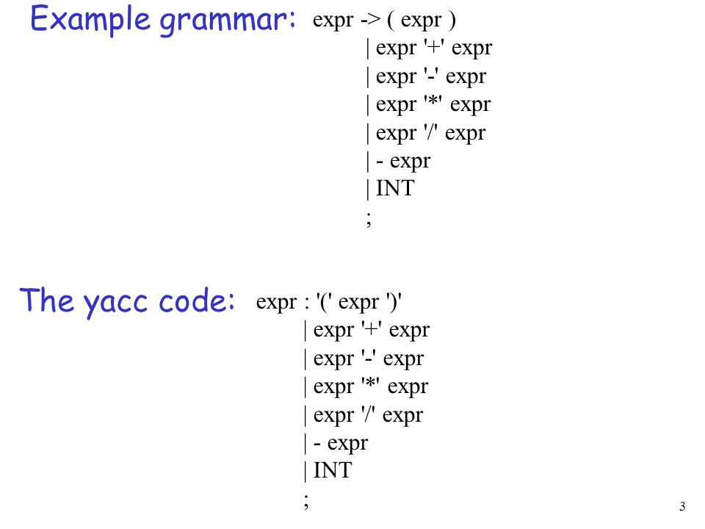

**PROGRAM**

**OUTPUT**

**CONCLUSION**